Buying a pool pass:
- Please go to the Glenshire Devonshire Website and click on the green button that states Purchase Pool passes
  - See Green button below:
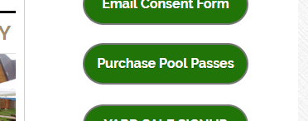
  - If you have never purchased passes before, then you’ll first need your account to be activated. Please email the office at glenshiredevonshire@gmail.com for a log in
  - If you know your login but can’t remember your password, please click Forgot your password and it will send you a link to reset your password.
- After logging in, you will be taken to the membership manager unless you have never logged-in before or if you haven’t purchased pool passes this year.
- You will need to ADD your family members under My Account at the top (do not ADD the person who is already on the account)
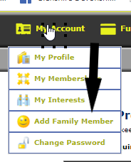

- Then you will need to click to Memberships:
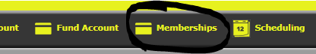
- This will bring to the Membership manager: 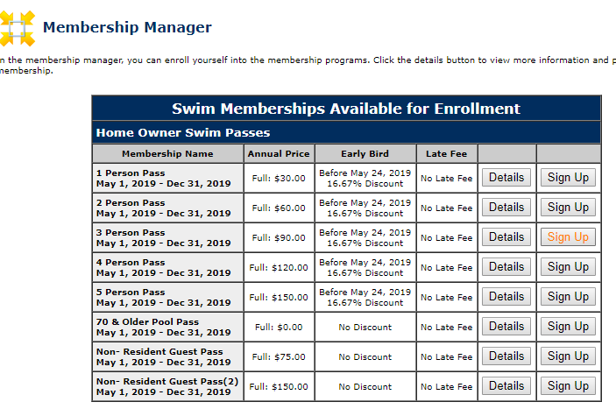

- Please click on SIGN UP for the number of passes you will be purchasing. All members must be living in the household unless you are purchasing a non-resident guest pass.
  - Non-resident guest passes are for non-family members, non-residents or nanny passes ($75/year) . you can purchase up to 2 of these passes however the total number of passes purchased can not exceed 5.
- Then select the family member(s) that you are purchasing a pass for. If you don’t see the person you are buying a pass for please go back to #3 and add a family member. Then hit Continue to payment.
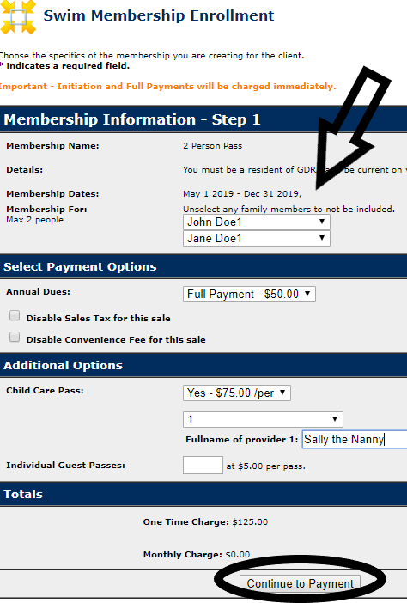
- Then you’ll be taken to Membership Payment - Step 2
There is no charge to pay by CC.
Check the Circle Pay in Store or Pay using CC/Debit
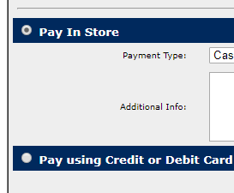

9. Please note you must change the billing address if your CC has different Billing Address than the home address. Otherwise you’ll get an error
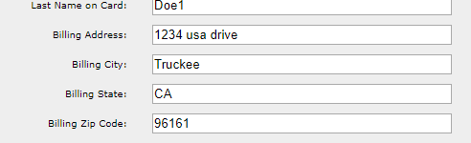
10. Hit purchase now and you should be all set!
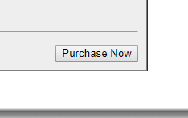
If you have any trouble at all please email or call. glenshiredevonshire@gmail.com
530-587-6202

